**A2 Peripheral devices and media**

Input devices

Task 1: Identify as many input devices along with explanation of each device indentified.

|  |  |
| --- | --- |
| **Input device name** | **Description of input device** |
|  |  |
|  |  |
|  |  |
|  |  |
|  |  |
|  |  |
|  |  |
|  |  |

Output devices

Task 2: Identify as many output devices along with explanation of each device indentified.

|  |  |
| --- | --- |
| Output device name | Description of output device |
|  |  |
|  |  |
|  |  |
|  |  |
|  |  |
|  |  |
|  |  |
|  |  |

Accessibility devices

Task 3: Identify as many devices along with explanation of each device indentified that would support a user with disabilities.

|  |  |
| --- | --- |
| Accessibility device name | Description of device |
|  |  |
|  |  |
|  |  |
|  |  |
|  |  |
|  |  |
|  |  |
|  |  |

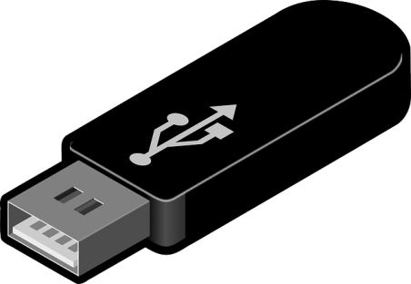Storage devices

Task 4: Describe each storage device and give adv and disadv of each storage device.

|  |  |  |  |
| --- | --- | --- | --- |
| **Type of storage device** | **Description** | **Advantages** | **Disadvantages** |
| 1. Hard Disk Drives |  |  |  |
| 1. Solid State Drives |  |  |  |
| 1. USB Flash Drives |  |  |  |
| 1. SD Cards |  |  |  |
| 1. Optical Disks |  |  |  |

Manual and Automatic processing

Task 5: Complete the questions below:

1. What is manual processing?
2. What is automatic processing?
3. Provide the differences between manual and automatic processing in the table below:

|  |  |
| --- | --- |
| **Manual processing** | **Automatic processing** |
|  |  |
|  |  |
|  |  |
|  |  |
|  |  |

**A2 Assessment Recap**

1. Ben is a blind student.

Describe two accessibility device which will help him to complete his IT Course and explain how each may be used. (4 Marks)

1. Passenger entry through a barrier after checking in for a flight and passing through security checks is controlled automatically generally with no human operator interventions.
   1. Describe two types of input device that could be used in this process. (4 Marks)
   2. Describe one output device that could be used in this process. (2 Marks)
   3. Explain why a human operator may also be present at the barrier (2 Marks)